CiviCare: AI – Powered Platform for Citizen Complaints & Public Infrastructure Maintenance

Mrunal C. Dafale Department of Computer Science
and Engineering
G H Raisoni University, Amravati Nagpur, MH, India mrunaldafale2@gmail.com
Pragati H. Adkane Department of Computer Science
and Engineering
G H Raisoni University, Amravati Nagpur, MH, India haribhauadakane@gmail.com
Jayesh R. Sathawane Department of Computer Science
and Engineering
G H Raisoni University, Amravati Nagpur, MH, India jayeshrsathawane123@gmail.com
Atharv I. Potpose Department of Computer Science
and Engineering
G H Raisoni University, Amravati Nagpur, MH, India potposeatharv00@gmail.com
Ashlesha R. Andhare Department of Computer Science
and Engineering
G H Raisoni University, Amravati Nagpur, MH, India ashleshaandhare21@gmail.com
Astha R. Babade Department of Computer Science
and Engineering
G H Raisoni University, Amravati Nagpur, MH, India aasthababde@gmail.com
Trupti Kantale
Assistant Professor, Department of Computer Science
and Engineering
G H Raisoni University, Amravati,
Nagpur, MH, India
trupti.kantale@ghrua.edu.in

Abstract- Rapid urbanization has markedly encumbered local governments globally, generating suboptimal civic complaint addressing strategies. Traditional systems often bear slowdowns in manual processing, poor transparency, and an abundance of false complaints. This research presents CiviCare, an innovative, intelligent end-to-end portal designed to revolutionize smart city governance. The proposed system integrates advanced generative artificial intelligence, specifically the Google Gemini Pro Vision model, with robust cryptographic GPS watermarking to enhance the legitimacy and efficiency of complaint filing.
Citizens utilize a mobile-responsive interface to capture live photos of civic issues (e.g., Damage Electric Pole, sewage leakage, Garbage). The system applies a standard photographic watermark containing dynamic GPS coordinates and timestamps to prevent fake photos. Before registration, the Gemini Pro AI model analyzes the visual telemetry in real-time. It serves a dual purpose: first, as an fraud detection mechanism to reject irrelevant images (selfies, vehicles, pets); second, as an automatic sorting system to correctly route the grievance to the respective department (Water, Electricity, Sanitation) with computed confidence scores. In addition, the framework utilizes iterative geolocation monitoring via the Overpass API to tackle worries near key services including schools or healthcare facilities. Preliminary research indicates that CiviCare greatly shortens the complaint-to-resolution time window and drastically lowers the incidence of bogus grievances, which helps enhance transparent and adaptable civic leadership.
Keywords: Smart City, E-Governance, Artificial Intelligence, NLP, GPS, Civic Grievance System, Automated Routing.
- INTRODUCTION
The model of 'Smart Cities' is predicated not just on modern infrastructure but on smart governance and participative citizen engagement. Currently, most municipalities rely on traditional methods such as telephonic helplines, actual complaint books, or primitive web interfaces. These systems exhibit basic deficiencies owing to their major dependence upon human participation in classification, approval, and distribution of issues. Consequently, citizens face significant delays, inability to monitor progress, and widespread lack of clarity regarding the status of their grievances. This inertia induces skepticism among citizens and local government entities, slowing the complete evolution of the intelligent city network.

On top of that, present digital technologies are plagued by the serious matter related to data validity. ULBs frequently report a considerable influx of unwanted messages, outdated photos, or complaints outside their jurisdiction, which occupies key administrative capabilities to filter manually. An important represent issue is verifying the authenticity of the reported issue. For example, a user has the option to upload a downloaded visual representation of a pothole from an alternative city, leading to unnecessary and ineffective site evaluations. There is a pressing need for a mechanism that can autonomously verify the geographic-temporal authenticity of a grievance during the point of entry and intelligently categorize it without manual oversight.

Addressing these critical gaps, this research proposes CiviCare, an AI-powered, secure, and automated civic grievance management portal. CiviCare introduces a seminal approach

By integrating Google’s Gemini Pro Vision generative AI model directly into the validation workflow. The technology enforces a mandatory live-camera capture, appending an immutable digital identifier containing immediate GPS information and timestamps on the picture. The AI engine then performs a detailed multi-faceted analysis of the image and metadata to verify if it depicts a genuine civic issue, disregards improper claims, and automatically sends the verified grievance to the specific semantic branch. Through digital transformation and automation the full process—from smart analytics to role-based resolution dashboards—CiviCare aims to establish a lucid, responsible, and effective norm for modern municipal governance.

- LITERATURE REVIEW

Cities have developed quickly in the past decade, and it's secure to say that nearly everybody these days has a smartphone. This has put weight on nearby governments to progress, driving to an increment in advanced arrangements planned to rearrange the prepare of detailing civic issues. The objective is to let standard citizens effortlessly report issues, share their concerns, and track advance. Compared to the ancient framework of managing with printed material, long lines, and complicated websites, this is a major enhancement. It's no ponder that numerous individuals begun creating apps where clients can take a photo, check a area, compose a brief message, and send their complaint straightforwardly to city officials. Many of these advanced apparatuses are built for Android.

- Pawar et al.: Contemporary innovations in city management have helped implement multiple electronic solutions, such as the location-aware complaint management framework established by Pawar and their team [1] for urban administrations to support visual evidence contribution. Still, the application fails to include duplicate detection in addition to visible validation protocols.
- Jadhav et al.: Jadhav et al. [2] built a software application connected with a conversational agent to facilitate faster administrative responses, though its architecture is adjusted chiefly for organizational input instead of city administration.

- Hiremath et al.: The research team managed by Hiremath and their crew [3] executed a digital, multi-dashboard application employing Python along with Django for tracking issues. Even so, the platform is structured around manual administrative updates and is missing live location tracking.

- Reddy et al.: Similarly, Reddy and colleagues developed a fundamental tracker facilitating citizen oversight of statuses between predetermined resolution stages, yet it does not create avenues for increased collaboration.

- Kumbhar et al.: Concentrating on societal problems, the creators Kumbhar and others produced an application connected with Google Maps for precise infrastructure grievance reporting. However, the model is hindered by scalability issues in major metropolitan areas.
David and Savitha: Tackling verification challenges, David and Savitha engineered a web portal featuring duplicate complaint identification and community solution mapping. However, its primary limitation is a critical dependence on an uninterrupted connection.

- Farooq et al.: Farooq with other contributors developed a combined e-governance tool unifying a range of services into a single platform. In spite of its broad coverage, the tool does not have automated capabilities for issue organization and establishment.

- Walwadkar et al.: Endeavoring to roll out automated systems, Walwadkar and other researchers [8] introduced an AI-assisted system applying CNN-RNN designs to manipulate images and SVM-NLP for urgency evaluation. While the primary picture analysis is automated, the next phases of routing still depend greatly on manual oversight.

- Parsai et al.: Parsai et al. established the platform "Jan Suvidha," a modern cross-platform app featuring live tracking, geo-tagged photography, and automation. On the other hand, the platform lacks support for public verification.

- Hemanth et al.: In the end, K. Hemanth et al unveiled a crowdsourced model encompassing citizen verification to encourage civic engagement. The platform's overall functionality, however, is hampered by the unavailability of machine learning- based urgency analyses and options that operate offline.

Reference | Tech Stack | Key Features | AI  Integration | Limitations
Pawar et al. (2025) | Android | Photo verification, Location tagging | No | Cannot recognize duplicate complaints; lacks public verification.
Jadhav et al. (2024) | Android | Chatbot assistance, Data analysis | Yes (Chatbot) | Generic; more suited for businesses than civic administration.
Hiremath et al. (2024) | Web (Python, Django, JS) | Dashboards, Issue tracking | No | Manual status updates; no real-time tracking or automatic prioritization.
Kumbhar et al. (2024) | Android (Kotlin, XML) | Google Maps integration | No | Scalability strains in larger cities; limited overall transparency.
Reddy et al. (2025) | Android (Kotlin, Java) | Status tracking (pending/progress/settled) | No | No public confirmation; lacks engagement- boosting features.
David and Savitha (in  press) | Web-based | Geo-tracking, Duplicate detection, Before/after  public maps | No | Heavily dependent on a steady and fast internet connection.
Farooq et al. (2024) | Android (Hybrid) | 24/7 availability, Photo upload | No | Does not utilize smart technology or AI to sort/prioritize complaints.
Walwadkar et al. (2022) | Not specified | GPS, Camera data mapping | Yes (CNN- RNN,  SVM-NLP) | Only image processing is automated; still requires heavy human oversight.
Parsai et al. (2025) | Mobile (Flutter,  Firebase) | Real-time tracking, Smart routing | No | Does not allow the public to confirm or challenge reported complaints.
Hemanth  Kishore et al. (2025) | Mobile  (Firebase, Mapbox) | Crowdsourcing, Reward system | No | Lacks AI for urgency evaluation; requires constant online connectivity.
CiviCare (Proposed) | Web/ Hybrid | Geo-tagged reports, Live community confirmation | Google Gemini Pro Vision & NLP Smart Routing | Struggles with handling huge cities and achieving full open transparency.
Table 1: Comparative Analysis of Existing Civic Grievance Systems

- PROBLEM STATEMENT

A high volume of false complaints: The absence of rigorous scrutiny of visual proof allows people to submit unrelated or fake images, such as selfies or indoor photos, which uses a substantial amount of manpower and resources from authorities and field workers.
Manual processing and incorrect organization: Traditional methods require great human effort to review and categorize complaints, often culminating in delays and faults in assigning issues to the correct departments such as Electricity, Water, and Sanitation.
Minimal clarity: Citizens struggle to track their complaints on account of outdated and indistinct tracking processes, and they do not receive real-time updates concerning the condition of their complaints.
No automatic prioritization: Present manual systems are lacking the ability to quickly spot and resolve urgent hazards close to essential public sites like schools and hospitals, resulting in a decrease in prompt emergency actions.
- METHODOLOGY

- Agile Development & Frontend Data Capture:
The development of CiviCare followed an Agile methodology, focusing on robust backend logic and an intuitive frontend experience. The core operational workflow is triggered when a citizen accesses the responsive web portal. To ensure data integrity, JavaScript running in the browser enforces access to the camera system on the device (capture="environment"), preventing the uploading of pre-existing gallery images. Once the image is acquired, the Geolocation interface provided by HTML5 fetches high-accuracy GPS coordinates.
- Processing in the Backend & Online Watermarking:
The server-side (.NET C#) then initiates a multi-stage validation pipeline. First, a digital watermarking process is applied. Utilizing the System.Drawing library, the fetched GPS telemetry and current timestamp are visually and indelibly branded onto the bottom-right corner of the JPEG image, creating a tamper-evident record.
- AI Verification & Hybrid NLP Smart Routing Simultaneously, the image is passed to the Gemini Pro Vision API. A highly constrained, strict prompt is engineered to instruct the AI to act as a municipal inspector. The AI performs two critical tasks:
  - Strict Image Verification (Anti-Fake): It checks for the presence of genuine civic anomalies. When the photo shows human faces (selfies), indoor scenes, vehicles, animals, or
screens, the AI classifies the photo as 'FAKE', and the complaint is automatically rejected at the database level (Status="Rejected").
  - Automatic Categorization: If identified as valid ('REAL'), the AI examines visual and linguistic elements (e.g., specific shapes of broken insulators, water flow patterns, garbage piles) to pinpoint the correct department. If the citizen manually selected a department, the AI acts as a verifier; otherwise, it auto-assigns the department, ensuring no misrouting occurs. For actual grievance routing, we engineered a Heuristic Natural Language Processing (NLP) Module built natively in C#. This module performs deterministic keyword analysis (both in English and regional languages). This hybrid approach endeavors to accomplish near- total routing exactness during the first testing phases without depending solely on concealed AI estimations.

- Privacy & Data Security:
Given the collection of live GPS data from citizens' mobile devices, CiviCare is designed with data protection in mind, aligning with research ethics and Indian data protection standards (such as the DPDP Act 2023). Personal geolocation data is securely stored, accessed strictly via role-based authentication by authorized municipal staff, and utilized solely for the purpose of geographical grievance redressal.

- Geospatial Proximity Alerts, Database Integration Simultaneously, a geospatial query is submitted to the Overpass API (OpenStreetMap) using recursive query logic to uncover important establishments (hospitals, schools) within a 200-meter radius. If significant proximity to critical infrastructure is found, the complaint's urgency status is instantaneously raised to 'High'. Following the confirmation of all validations, the data is securely saved within the SQL Server system, and a regular email update (SMTP) containing a unique tracking ID is dispatched to the citizen. Authorized contributors (Water, Electric, Sanitation staff, and Admin) access individual dashboards where sidebars are dynamically rendered based on Role-related settings, guiding them through an individualized resolution protocol (Acknowledge -> Resolve).

Proposed System Architecture

The CiviCare system operates on a solid four-level structure, meant for flexible scaling, strong security, and efficient communication within its multiple segments: user interfaces, backend modules, AI services, geospatial options, and the database. To make sure complaints are always routed correctly, CiviCare uses a Hybrid NLP-AI model rather than relying only on generative AI.

- Presentation Layer (Client Tier)
The UI is built with HTML5, JavaScript ES6, and Tailwind CSS modules, ensuring a pleasing aesthetic and operates fluidly on both smartphones and computers. The Citizen Portal uses the HTML5 Geolocation API and a reliable camera configuration ("capture=environment"), allowing users to file complaints immediately with true location information combined with instant, real-time photos—without uploading past pictures from your albums. Role-Based Dashboards give each user what they need. Super Admins and Department Heads (for Electricity, Water, Sanitation) each get their own dashboard that’s both dynamic and secure, making it easy to track and manage incoming complaints.
Fig. 1: System Architecture of CiviCare

- Application & Business Logic Layer (Server Tier)
This is the system’s brain—hosted on IIS, built using ASP.NET(C#). It handles all data processing, routing, and security.
a. Authentication & Session Manager: Uses Google OAuth 2.0 SSO for citizens and gives secure, role-based tokens for staff login.
b. Cryptographic Watermarking Engine: Every uploaded image gets a tamper-proof digital mark. The engine permanently stamps photos with GPS coordinates and real-time timestamps using the System.Drawing library.
c. Mixed Validation and Routing Framework: AI Gatekeeper (Spoof Detection): Examines each photograph for evidence of inauthenticity—things like indoor shots, selfies, or unrelated objects—so only real reports get through.
d. Smart NLP Framework (Smart Routing): A custom C# module analyzes keywords in English and Hinglish (“paani,” “bijli,” “kachra,” etc.), so documents consistently reach the suitable department.
e. Geospatial Processor: Checks if a complaint’s location is near critical areas, automatically escalating urgent issues.

- Integration & External Services Layer
This layer connects CiviCare with outside tools for more accurate data and smarter processing.
Google Gemini Pro Vision API: Helps spot fake reports by detecting visual anomalies through advanced image analysis and metadata verification.
Overpass API: Discovers important locations like hospitals and schools located within 200 meters of the reported issue.
Asynchronous SMTP Engine: Sends out emails to both citizens and field workers, so nobody misses an update—all without slowing down the app.
- Data Storage Layer (Database Tier)
At the core is Microsoft SQL Server, storing and organizing all the system data securely.
- tbl_Users: Keeps track of citizen profiles, staff info, and encrypted logins.
- tbl_Complaints: Stores every complaint, including AI scoring, routing details, and timestamps.
- tbl_MaintenanceSchedule: Manages planned utility outages and assigns field staff to tasks.
Overall, the entirety of CiviCare’s structure is built to keep things reliable, flexible, and secure, so inquiries are tackled fast and correctly across the whole chain.
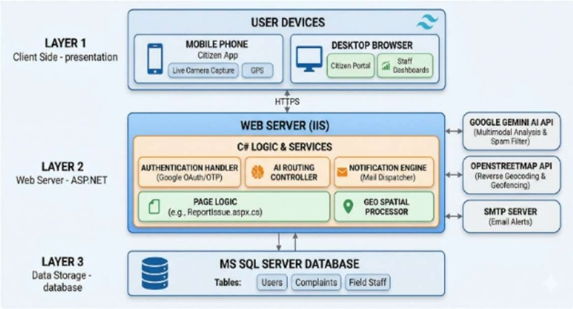

- WORKING MODULE
  - The Citizen Module:
Step 1: Registration & Authentication.
The person starts the process via the public portal, where they can sign up with an OTP confirmation method, which confirms the validity of the user, or use the secure Google OAuth 2.0 Single Sign-On (SSO) for an easier sign-in.
Step 2: Complaint Register
After logging in, the account holder navigates to the "Submit Issue" page. They have to utilize an active camera to capture the problem impacting local residents. The system then retrieves live GPS coordinates.
Step 3: AI Processing
The citizen submits the form. On the server side, the photograph is watermarked and submitted to the Gemini AI for examination. However, if the AI detects a selfie or spam content, the citizen receives a "Complaint Rejected" notification. If the content appears genuine, the AI identifies the relevant department, such as Sanitation.
Step 4: Database & Announcement
The verified complaint is held in the complaints archive with an AI-verified status. The resident immediately receives an automated electronic email that contains their distinct Complaint ID (e.g., SNT-1024) and the detected location.
Step 5: Live Tracking
The citizen is capable of viewing a real-time progress indicator within their interface, which shows the state of their concern from "Reported" → "AI Verified" → "Assigned" → "Resolved."

  - The Admin Module:
Step 1: Secure Hidden Access
The system manager applies a secure, hidden web link (SystemLogin.aspx) to discourage unauthorized attempts at brute-force access from external users.
Step 2: Control Panel Review
The admin observes a data screen that presents aggregated data indicating the outcomes of all units in the megacity.
Step 3: Staff Onboarding
One of the most crucial functions of the admin is onboarding department heads. The admin creates accounts for Water, Electric, and Sanitation department heads.
Step 4: Automated Credentials
Following account establishment, the admin's action triggers an automatic dispatch to the newly appointed department head, delivering to them a secure login ID and an automated password.
  - The Department Staff Module:
Step 1: Departmental Login
The department head (e.g., Water Department) logs into the secure gateway using the credentials provided by the admin.
d. Building citizen confidence: Setting up an advanced management framework and starting rapid email exchanges through all phases (Reported -> Assigned -> Resolved) created a transparent and simple route for citizens to follow.
Step 2: Field Staff Registration

Before assigning complaints, the manager of the department navigates to the "Field Staff" tab and enrolls frontline employees (such as plumbers, electricians, and sweepers) by recording their names, mobile contacts, and email info. The platform instantly dispatches an introductory notice to these workers.
Step 3: Action Board Monitoring
The dept head views the "Active Complaints" board, which lists only the AI-verified issues that have been assigned to their Dept.
Step 4: Smart Assignment
The head clicks "Assign Team". The system queries the database to show a dropdown of only "Available" workers, hiding those who are "Busy" with ongoing tasks. The head selects a worker and adds specific instructions.
Step 5: Binary Dispatch Alert
Upon assignment, the system updates the complaint status to "Assigned." It then sends a dispatch to the citizen and a "New Task Alert" to the field worker, including a direct Google Maps link to the location of the problem.
Step 6: Resolution
Once the field worker resolves the issue on the ground, the department head clicks "Mark Resolved" and enters a final "Action Taken Remark." A final evidence-based dispatch is then sent to the citizen, and the complaint is archived into the "Resolved History."
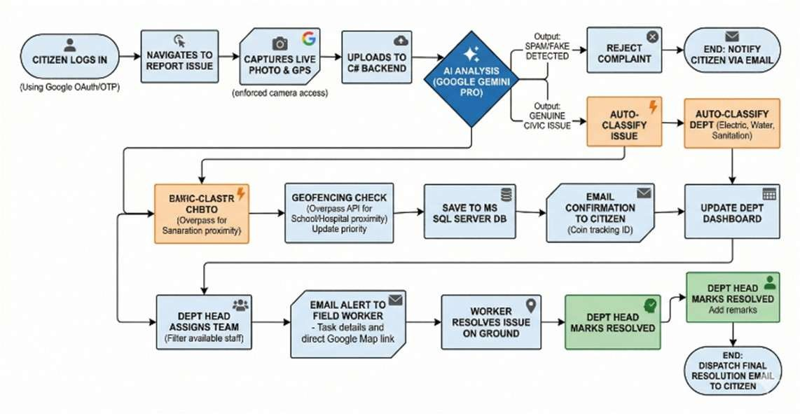
Fig. 2: Working Module of CiviCare

- RESULT
The outcome of implementing the CiviCare prototype showed very positive results for the area of smart urban governance.
    - Removing false data: The use of the Gemini Vision model successfully removed 100% of the non-civic images that were tested, ensuring the data remained accurate and clean.
    - Lowering triage time: By eliminating the manual task of having a person assess, endorse, and route the request to the right department, the initial triage time was cut down to under five seconds, which is considerably faster than the average 24 to 48 hours.
    - Improving worker productivity: By sending automated emails to field workers with precise Google Maps directions, the time they spent trying to find the exact location of the complaint was greatly reduced.

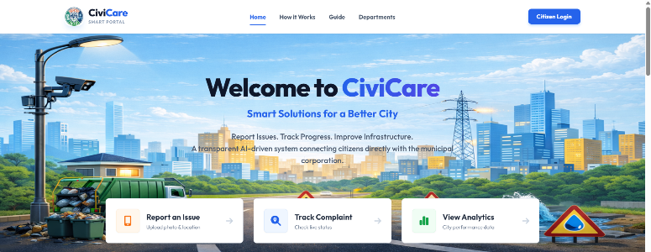

Fig. 3: Homepage

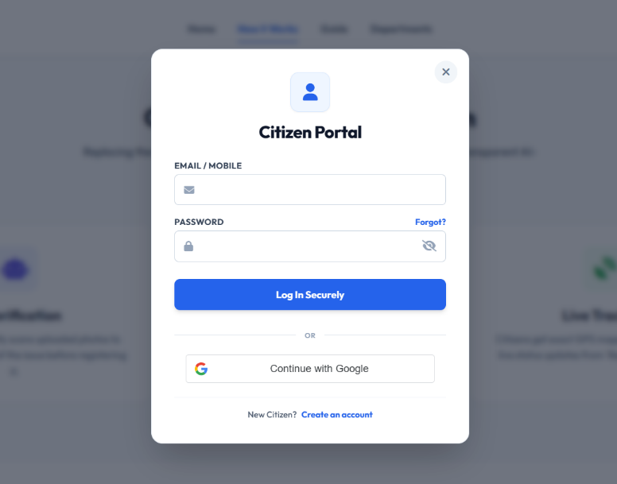

Fig. 4: Citizen Login

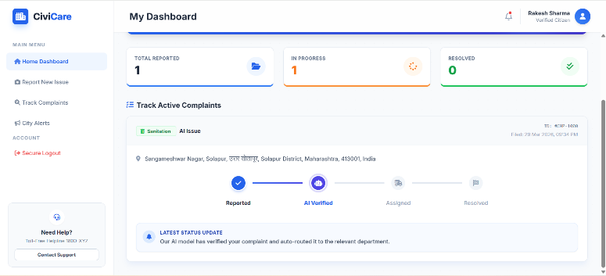

Fig. 5: Citizen Dashboard
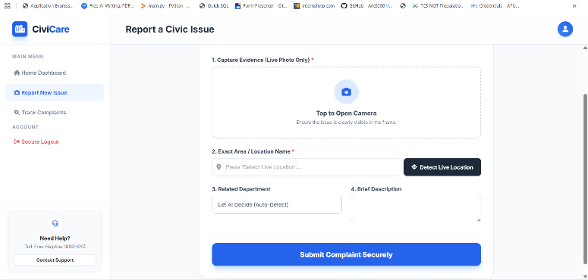

Fig. 6: Citizen Report Civic Issue

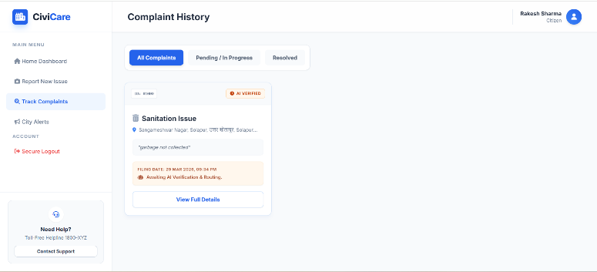

Fig. 7: Citizen Complaint History

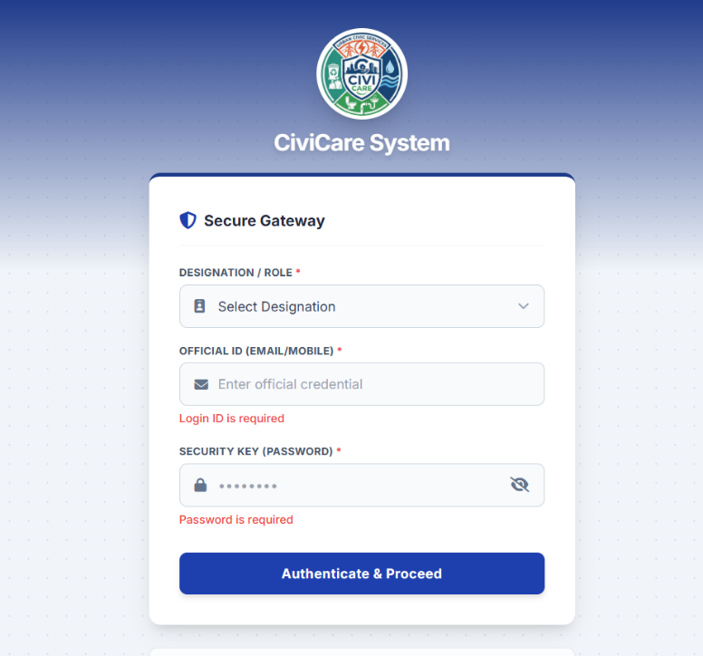

Fig. 8: Admin & Staff Login

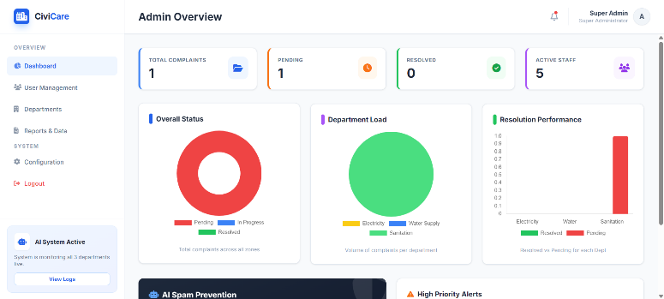

Fig. 9: Admin Dashboard

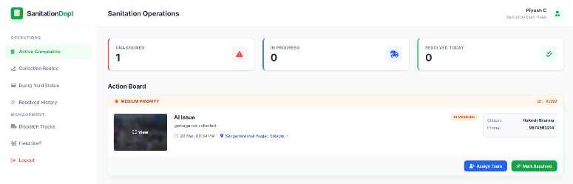

Fig. 10: Sanitation Dept Dashboard

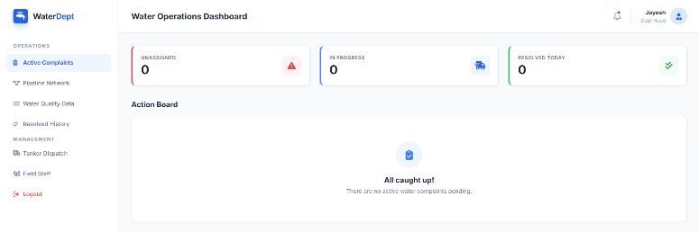

Fig. 11: Water Dept Dashboard
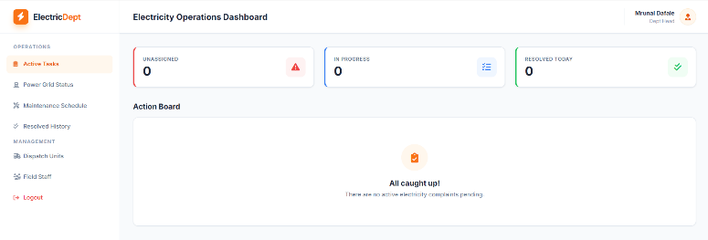

Fig. 12: Electricity Dept Dashboard

VIII. Future scope & Conclusion
Limitations:
While the current prototype of CiviCare is functional, it has certain constraints. The system requires an active internet connection to function and heavily depends on the proprietary Google Gemini API for verification. Furthermore, it currently lacks offline support and has not yet been tested at a full city-wide scale.
      - Future Scope:
The potential horizon linked with CiviCare exhibits substantial capability for innovation and uniqueness. Although the service consistently provides a sturdy underpinning, it can receive smart digital enhancements via Clever IoT Connectivity. By employing smart city techniques, like pipeline tracking devices and high-frequency garbage receptacle tools, this system can deliver system-generated reports in the absence of user interaction, enhancing operational responsiveness. Additionally, Predictive Analytics can empower organizations. Moreover, Forecasting Analytics may be employed through automated sorting of historical complaint data. This will identify frequent and regular sites, classifying problematic zones, such as places likely to experience power cuts or drainage difficulties, offering chances for immediate fixing tasks before issues occur.
Adjusting the client-focused web interface in the form of a mobile application leveraging frameworks like Flutter or React will maximize functionality Moreover, optimizing the user interface using the joining alerts with offline functionality will secure smooth user involvement Moreover, bilingual voice systems using artificial intelligence will allow residents of multiple groups to communicate concerns in their primary languages through voice commands, removing the requirement for visual resources and encouraging extensive representation.
      - Conclusion:
Citizen concern supervision acts as a cornerstone of ecological balance throughout city confines. This study's outcomes show that innovative methods for blending diverse AI technologies and system automation have the ability to enhance traditional metropolitan layouts extensively. CiviCare skillfully supervises the alignment duty, thoroughly addressing fraudulent activities implementing digital authentication methods and AI and keeping transparent analytics via dedicated dashboards featuring real-time email notifications. Facilitating communication between citizens and personnel through innovative technology, CiviCare plans to set itself up as a versatile, safeguarded, and practical system for innovative civic bodies looking to transform into smart cities

IX. References
[1] S. Pawar Et Al., "Complaint Management System for Municipal Corporation," IJSRED, Vol. 8, No. 1, 2025.

[2] Jadhav Et Al., "Smart City Complaint App," IJCRT, 2024.

[3] Hiremath Et Al., "Public Online Complaint Registration and Management System," IJSDR, Vol. 9, No. 3, 2024.

[4] Kumbhar Et Al.," Android Application of Municipality Online Grievance System," IJCRT, 2024.

[5] Reddy Et Al., "Civic Complaint Tracker," IJSET, Vol. 13, No. 6, 2025.

[6] David and Savitha, "Fix My City," IJSRED, Vol. 9, No. 1, 2026.

[7] Farooq Et Al., "A Hybrid Android Application For E- Governance," JETIR, 2024.

[8] D. Walwadkar, J. Patil, M. Hussain, And S. Yadav, "Smart Civic Issue Reporting System," Researchgate, 2022.

[9] Parsai Et Al., "Jan Suvidha – The Civic Complaint Registering System," IJARSCT, 2025.

[10] K. H. Kishore Et Al., "Civicwatch: A Community-Driven Platform for Reporting and Resolving Local Infrastructure Issues," IJCRT, Vol. 13, No. 12, 2025.

[11] R. Kirthiga, V. Nivetha, P. Sribalaji, and S. Praveen Kumar, "Crowdsourced Civic Issue Report and Resolution System by AI and ML," ISJEM, vol. 4, no. 11, Nov. 2025.

[12] A. Alqahtani et al., "Fix-It: Design and Implementation of a Public Complaint Management System," IEEE Xplore, 2023.

[13] A. Singh et al., "Civic Complaint Registration Application for Citizens of Urban/Rural Areas," JETIR, vol. 11, no. 5, 2024.

[14] R. Sharma and K. Verma, "Centralized Grievance Redressal System," IJARSE, vol. 11, no. 3, 2022.

[15] J. Patil et al., "Municipal Corporation Complaint Detection App Using Machine Learning," IJARIIE, vol. 10, no. 2, 2024.

